|  |  |  |  |
| --- | --- | --- | --- |
| **Lyng Primary School Knowledge Organiser** | | | |
| **Topic:** | **The Maya Civilisation - Why do volcanoes occur?** | Year 6  Civilisation, Communication and Inventions | Autumn 2 |

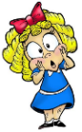

**Background information:**

This educational topic will cover the formation, types and functions of volcanoes providing an understanding of plate tectonics and volcanic activity. This captivating study not only fosters scientific curiosity, but also encourages critical thinking as the children grasp the natural forces shaping our planet.

|  |  |
| --- | --- |
| **What Step On and Goldilocks words will I use?** | |
| **Spelling** | **Definition** |
| Active | A volcano that has had at least one eruption during the past 10,000 years. |
| Ash cloud | A mass of ash, dust and debris above the volcano after an eruption. |
| Boundary | are the edges where two tectonics **plates** meet |
| Composite Volcano | steep-sided, symmetrical cone-shaped volcano |
| Constructive margin | a boundary where the plates move apart |
| Conservative margin | a boundary where the plates slide past each other |
| Continental plate | irregularly shaped slab of solid rock, generally composed of land |
| Convection current | Transfer heat from one place to another and cause molten liquids to rise and fall within the Earth’s crust. |
| Destructive margin | A margin where an oceanic and continental plate move towards each other. |
| Dormant | one that hasn't erupted in the past 10,000 years |
| Eruption | when magma is released from a volcano |
| Exclusion zone | an area of land that is closed off to the public to protect the citizens during an eruption |
| Extinct | A volcano that geologists do not expect to ever erupt again |
| Fault line | a break or fracture in the ground that occurs when the Earth's tectonic plates move |
| Lava | molten rock is erupted onto the Earth's surface |
| Magma | molten rock found below the earth's surface |
| Magma chamber | a large pool of liquid rock beneath the surface of the Earth |
| Natural hazards | Natural (as opposed to man-made) events that kill people or damage property or the environment. |
| Oceanic plate | A tectonic plate mainly composed of water |
| Pyroclastic flow | avalanches containing hot volcanic gases, ash and volcanic bombs, they can reach 70mph |
| Secondary vent | smaller outlets through which magma escapes |
| Super-volcano | any volcano capable of producing a volcanic eruption where the contents is over 1,000 km3 |
| Vent | an opening in the earth's crust |
| Volcanic bomb | is a mass of molten rock larger than 64 mm in diameter |

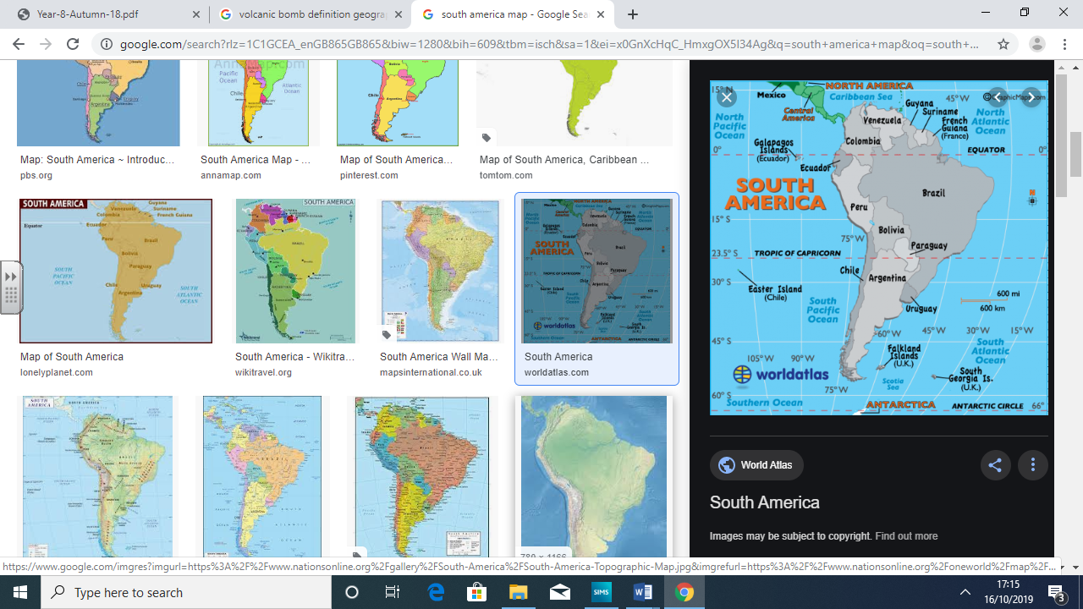

**Enquiry questions that we shall investigate during the topic:**

* What happens during a volcanic eruption?
* What causes volcanoes and earthquakes?
* Why do people live near volcanoes?
* What is the Pacific Ring of Fire?
* How is the climate different in South America compared to the UK?
* Does the need for a resource affect everyone?

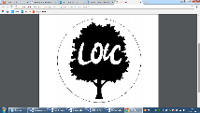

|  |
| --- |
| **Geographical study** |
| **Topography and human impacts**   * Analyse tectonic plate maps * Cross-sectional diagrams of volcanos and their structure * Diversity of land in South America and justification for the location of volcanic activity * Population distribution and density in South Americ * Explain the land use in the region of Colima * Analyse the environmental impact of substance and agricultural farming. |

**Fieldwork Opportunities**

Canal Walk – plastic pollution   
(Science and Eco-schools)

**Significant places**

* South America
* Nazca plate & Cocos plate
* North America plate

Mexico & Colima

**Our Storytelling Approach to enhance engagement**

|  |  |  |
| --- | --- | --- |
| **People:**  Citizens of Colima  (Jorge Mendes – he was there at the last eruption and survived. He thinks that nothing will happen to him even though volcanologists suspect the eruption will be the most destructive yet) | **Place:**  Colima, Mexico | **Problem:**  The volcano is about to erupt and the citizens need to evacuate the area. Where are they going to go? How are they going to get there? |

**Map to be studied**

**Key facts and locations**

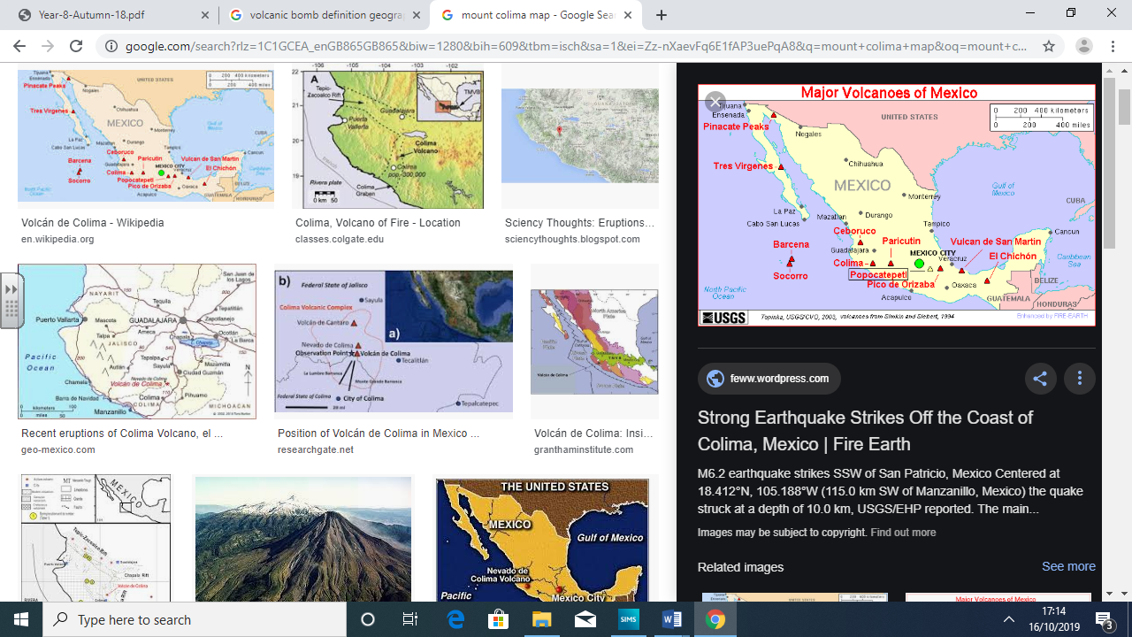

|  |  |
| --- | --- |
| **Colima** | **South America** |
| * The Volcan de Fuego is an active stratovolcano, the most explosive and dangerous in all of Mexico. * Colima volcanic complex is the most prominent volcanic center of the western Mexican Volcanic Belt. * The population of Colima is 711,235. * The capital city of Colima is ‘Colima City’. * Colima is the fourth smallest state in Mexico and has the smallest population, but has one of Mexico's highest standards of living and the lowest unemployment. * Cropland covers 27% of the state's territory, with another 28% dedicated to pasture. Forest covers 35% with the rest composed of bodies of water and urban areas. * El Chanal is located four km north of the city of Colima. It is a complex of pyramid platforms with stairs, a Mesoamerican ballcourt and a number of plazas. A distinctive feature of the site are stones with glyphs that are found on stairways | * South America is home to two of the largest countries in the world – Brazil and Argentina. * The Amazon River is located in South America. * The following countries make up South America as a continent: Venezuela, Argentina, Uruguay, Bolivia, Suriname, Brazil, Peru, Chile, Paraguay, Colombia, Guyana, and Ecuador. * South America is a continent in the Western Hemisphere, mostly in the Southern Hemisphere, with a relatively small portion in the Northern Hemisphere. * The Tropic of Capricorn and the Equator run through South American. * Spanish is largely spoken in South American countries. |

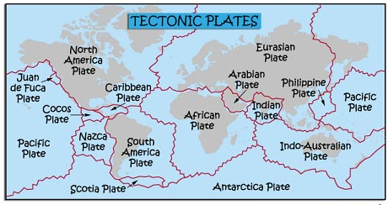

**Agreed Outcome**

Newspaper report recalling the events of the Colima eruption.

|  |  |  |  |
| --- | --- | --- | --- |
| **Lyng Primary School Knowledge Quiz** | | | |
| **Geography Topic:** | **The Ancient Maya** | Year 6  *Civilisations, Communication and Inventions* | Autumn 2 |

**Our Mayan Geography Quick Quiz**

|  |  |  |
| --- | --- | --- |
| 6. What is the human impact of a volcanic eruption? | **S** | **E** |
|  |  |  |

|  |  |  |
| --- | --- | --- |
| 7. At which plate boundary to tectonic plate push towards each other? | **S** | **E** |
| Conservative |  |  |
| Constructive |  |  |
| Destructive |  |  |

|  |  |  |
| --- | --- | --- |
| 8. Which country is Colima situated in? | **S** | **E** |
| Mexico |  |  |
| Bolivia |  |  |
| Guatemala |  |  |

|  |  |  |
| --- | --- | --- |
| 1. What is the name of the area evacuated during an eruption? | **S** | **E** |
| No-go area |  |  |
| Suspension Zone |  |  |
| Exclusion Zone |  |  |

|  |  |  |
| --- | --- | --- |
| 1. Why might people need to be evacuated before an eruption even occurs? | **S** | **E** |
|  |  |  |

|  |  |  |
| --- | --- | --- |
| 1. Which of the following is a country in South America | **S** | **E** |
| 1. Norway |  |  |
| 1. Brazil |  |  |
| 1. Egypt |  |  |

|  |  |  |
| --- | --- | --- |
| 1. List 3 features of a volcano | **S** | **E** |
|  |  |  |

|  |  |  |
| --- | --- | --- |
| 1. The Mid-Atlantic Ridge is an underwater mountain range. | **S** | **E** |
| True or False? |  |  |

|  |  |  |
| --- | --- | --- |
| 1. What is Mount Colima known as to locals? | **S** | **E** |
| Volcan de Fuego |  |  |
| A big problem |  |  |
| The Volcano of fire |  |  |

|  |  |  |
| --- | --- | --- |
| 1. Which type of farming is done to make a profit? | **S** | **E** |
| Agricultural |  |  |
| Subsistence |  |  |
| Recreational |  |  |